**The correct way to write the above Q1 and Q2 code** is as below:  
  
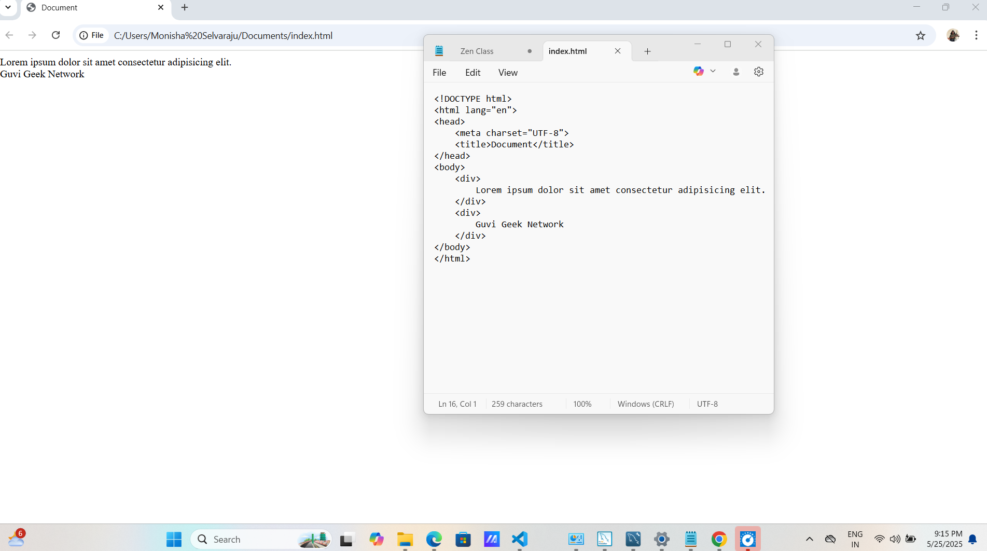

**When tried Q2. Code below is the output:**  
  
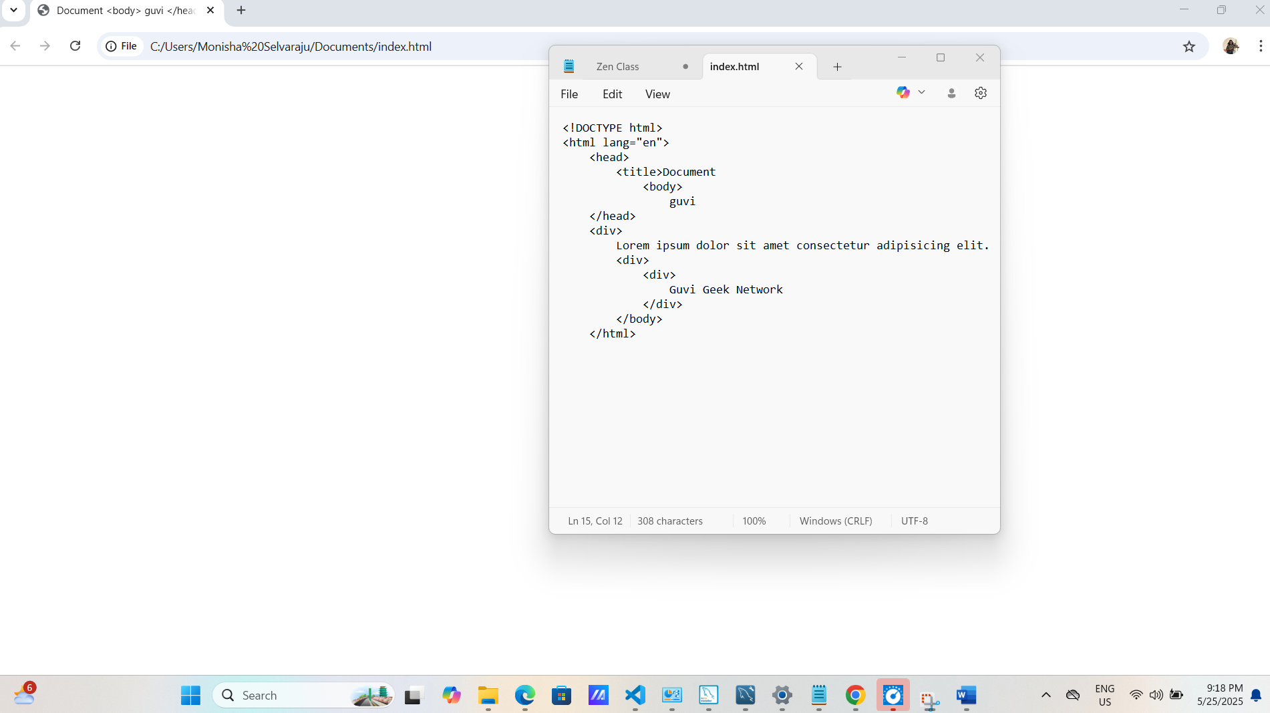

Q3. Design a contact form with all fields as required.

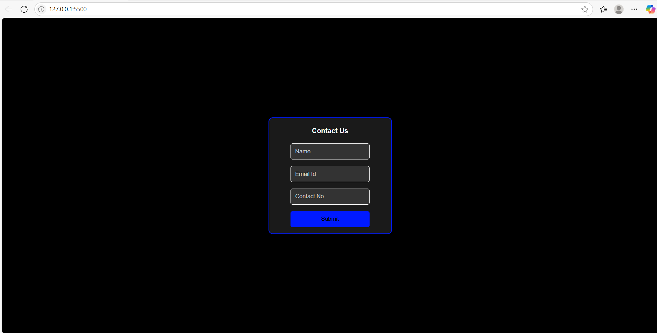  
  
styles.css:  
  
body {

    background-color: black;

    display: flex;

    align-items: center;

    justify-content: center;

    height: 100vh;

    margin: 0;

    font-family: Arial, sans-serif;

}

.contact-form {

    border: 2px solid rgb(0, 26, 255);

    padding-left: 50px;

     padding-right: 50px;

    border-radius: 10px;

    background-color: #1a1a1a;

    /* width: 90%;

    height: 85%; */

    display: flex;

    flex-direction: column;

}

.contact-form h4 {

    color: white;

    text-align: center;

    margin-bottom: 20px;

}

.contact-form input {

    margin-bottom: 15px;

    padding: 10px;

    border: 1px solid rgb(255, 255, 255);

    border-radius: 5px;

    background-color: #333;

    color: white;

}

.contact-form input::placeholder {

    color: #ccc;

}

.contact-form button {

    margin-bottom: 15px;

    padding: 10px;

    border: 1px solid rgb(0, 26, 255);

    border-radius: 5px;

    background-color: rgb(0, 26, 255);

    color: black;

}

Index.html:

<!DOCTYPE html>

<html lang="en">

<head>

    <meta charset="UTF-8">

    <title>Simple Contact Form</title>

    <link rel="stylesheet" href="styles.css" />

</head>

<body>

    <form class="contact-form">

        <h4>Contact Us</h4>

        <input id="name" type="text" placeholder="Name" required />

        <input id="email" type="email" placeholder="Email Id" required />

        <input id="contact" type="tel" placeholder="Contact No" required />

        <button type="submit" >Submit</button>

    </form>

</body>

</html>

1. Q4. Use certain HTML elements to display the following in a HTML page.  
     
   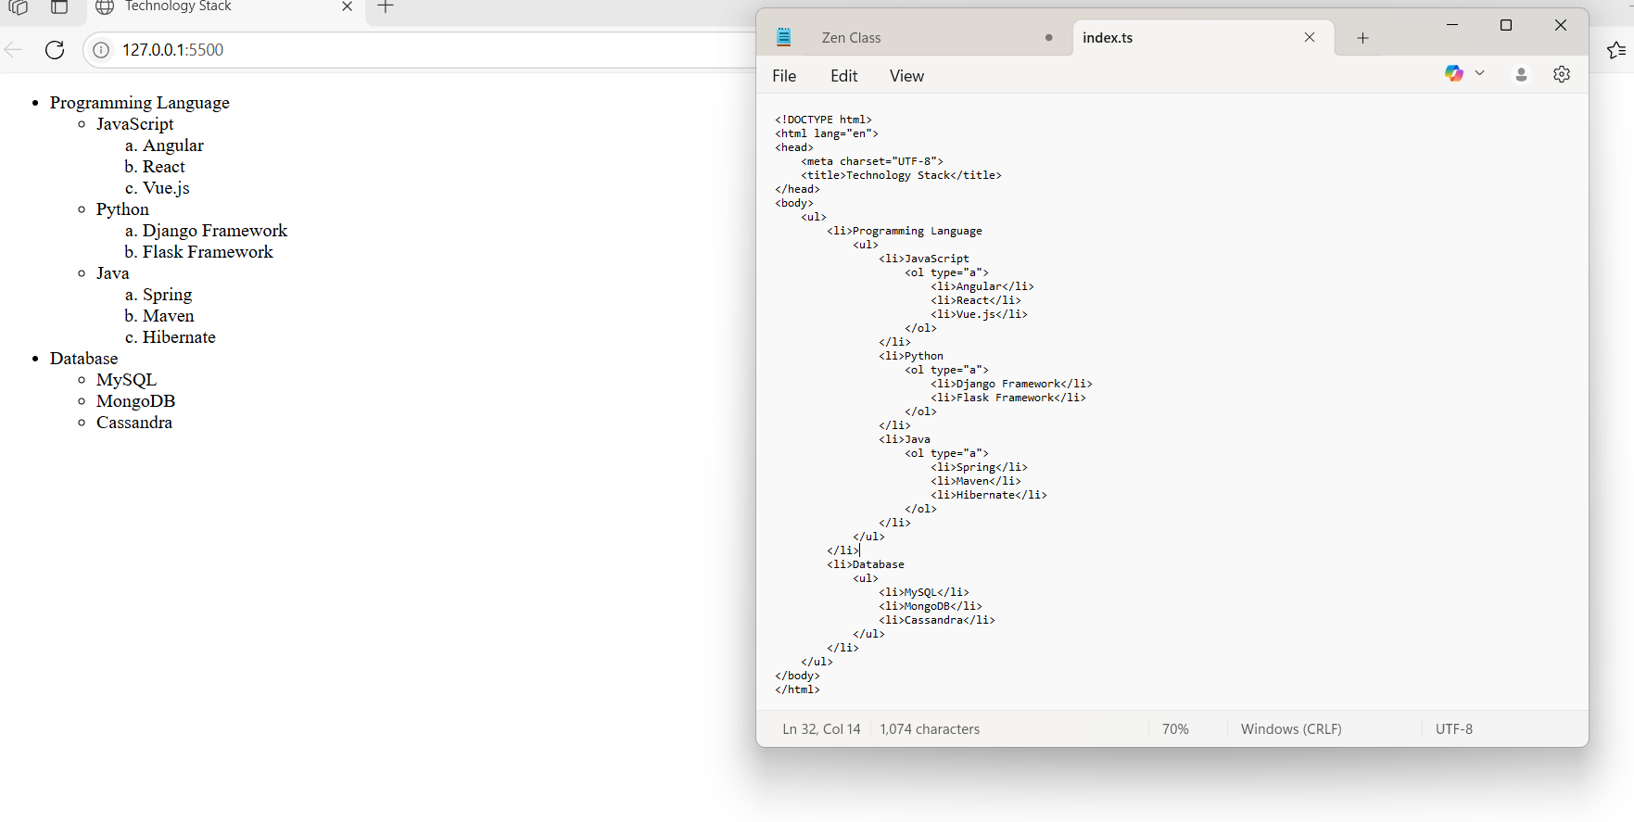

Q5.  
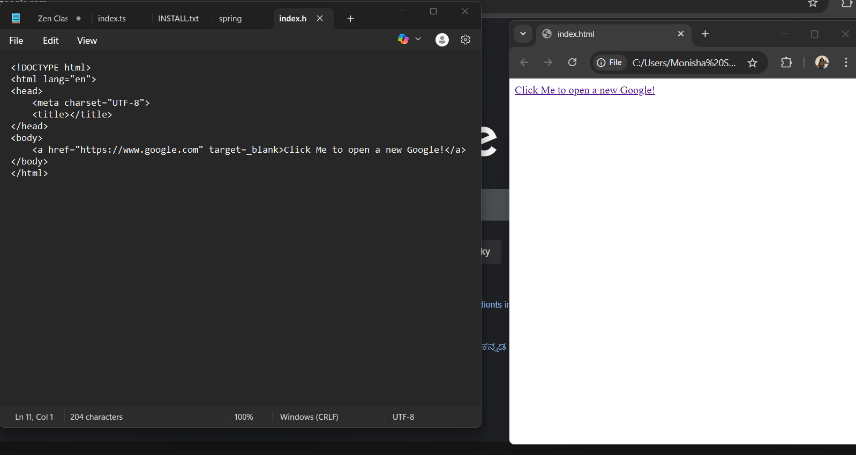  
  
Q6.

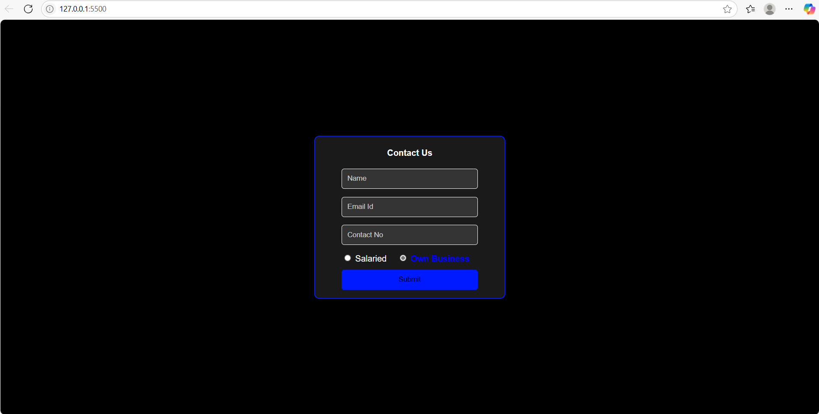

styles.css:  
  
body {

    background-color: black;

    display: flex;

    align-items: center;

    justify-content: center;

    height: 100vh;

    margin: 0;

    font-family: Arial, sans-serif;

}

.contact-form {

    border: 2px solid rgb(0, 26, 255);

    padding-left: 50px;

     padding-right: 50px;

    border-radius: 10px;

    background-color: #1a1a1a;

    /* width: 90%;

    height: 85%; */

    display: flex;

    flex-direction: column;

}

.contact-form h4 {

    color: white;

    text-align: center;

    margin-bottom: 20px;

}

.contact-form input {

    margin-bottom: 15px;

    padding: 10px;

    border: 1px solid rgb(255, 255, 255);

    border-radius: 5px;

    background-color: #333;

    color: white;

}

.contact-form div {

    color: white;

}

.contact-form input::placeholder {

    color: #ccc;

}

.contact-form button {

    margin-bottom: 15px;

    padding: 10px;

    border: 1px solid rgb(0, 26, 255);

    border-radius: 5px;

    background-color: rgb(0, 26, 255);

    color: black;

}

input[type="radio"]:checked + label {

    color: blue;

    font-weight: bold;

}

label {

    cursor: pointer;

    margin-right: 15px;

}

index.html:  
  
<!DOCTYPE html>

<html lang="en">

<head>

    <meta charset="UTF-8">

    <title>Simple Contact Form</title>

    <link rel="stylesheet" href="styles.css" />

</head>

<body>

    <form class="contact-form">

        <h4>Contact Us</h4>

        <input id="name" type="text" placeholder="Name" required />

        <input id="email" type="email" placeholder="Email Id" required />

        <input id="contact" type="tel" placeholder="Contact No" required />

       <div>

            <input type="radio" id="salaried" name="employeeType" value="salaried" required />

            <label for="salaried">Salaried</label>

            <input type="radio" id="business" name="employeeType" value="business" checked/>

            <label for="business">Own Business</label>

        </div>

        <button type="submit" >Submit</button>

    </form>

</body>

</html>  
  
Q9.  
  
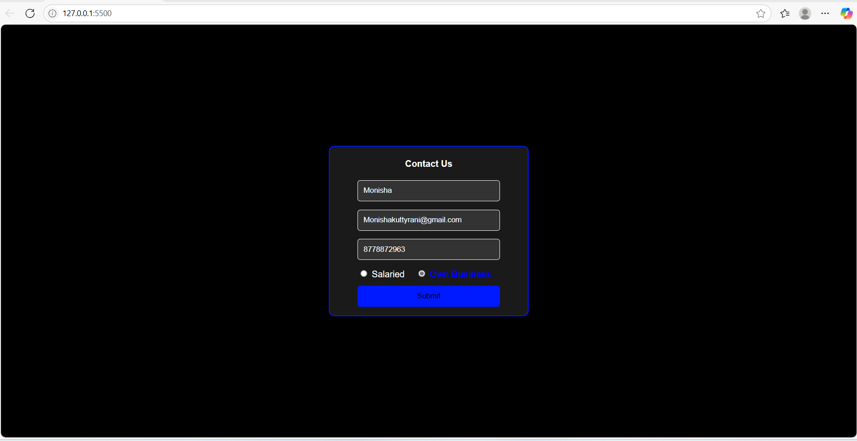  
  
index.html:  
  
<!DOCTYPE html>

<html lang="en">

<head>

    <meta charset="UTF-8">

    <title>Simple Contact Form</title>

    <link rel="stylesheet" href="styles.css" />

</head>

<body>

    <form class="contact-form">

        <h4>Contact Us</h4>

        <input id="name" type="text" placeholder="Name" value="Monisha" required />

        <input id="email" type="email" placeholder="Email Id" value="Monishakuttyrani@gmail.com" required />

        <input id="contact" type="tel" placeholder="Contact No" value="8778872963" required />

       <div>

            <input type="radio" id="salaried" name="employeeType" value="salaried" required />

            <label for="salaried">Salaried</label>

            <input type="radio" id="business" name="employeeType" value="business" checked/>

            <label for="business">Own Business</label>

        </div>

        <button type="submit" >Submit</button>

    </form>

</body>

</html>

styles.css:  
  
body {

    background-color: black;

    display: flex;

    align-items: center;

    justify-content: center;

    height: 100vh;

    margin: 0;

    font-family: Arial, sans-serif;

}

.contact-form {

    border: 2px solid rgb(0, 26, 255);

    padding-left: 50px;

     padding-right: 50px;

    border-radius: 10px;

    background-color: #1a1a1a;

    /* width: 90%;

    height: 85%; */

    display: flex;

    flex-direction: column;

}

.contact-form h4 {

    color: white;

    text-align: center;

    margin-bottom: 20px;

}

.contact-form input {

    margin-bottom: 15px;

    padding: 10px;

    border: 1px solid rgb(255, 255, 255);

    border-radius: 5px;

    background-color: #333;

    color: white;

}

.contact-form div {

    color: white;

}

.contact-form input::placeholder {

    color: #ccc;

}

.contact-form button {

    margin-bottom: 15px;

    padding: 10px;

    border: 1px solid rgb(0, 26, 255);

    border-radius: 5px;

    background-color: rgb(0, 26, 255);

    color: black;

}

input[type="radio"]:checked + label {

    color: blue;

    font-weight: bold;

}

label {

    cursor: pointer;

    margin-right: 15px;

}  
  
Q10.  
  
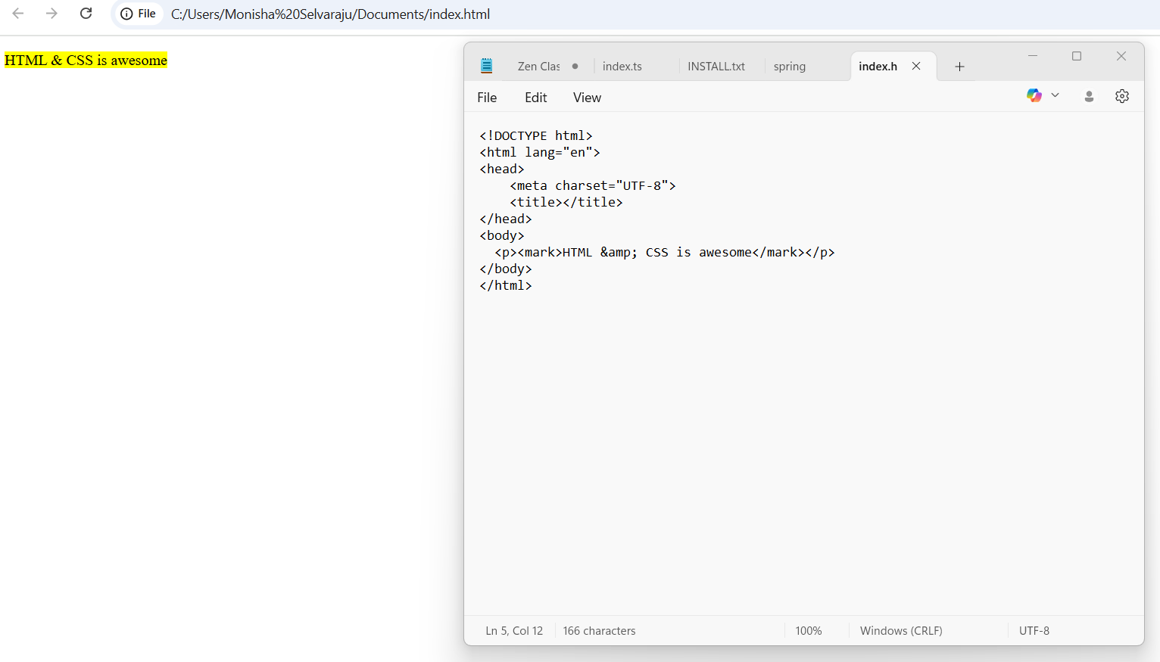

Q11.  
  
